Guidelines for the Rehabilitation, Maintenance, and Improvement of Properties in the Laytonsville
Historic District

Table of Contents
INTRODUCTION 1
GENERAL DESIGN ELEMENTS 2
Architectural Detail 2
Scale/Streetscape 2
Color 2
Building Orientation 2
Lighting 2
SPECIFIC DESIGN ELEMENTS 3
Masonry and Foundations 3
Foundations 3
Cleaning 3
Paint 3
Masonry Repair 4
Repointing 4
Siding 5
Doors and Windows 7
Doors 7
Screen Doors 7
Windows 7
Storm Windows 8
Roofs 9
Chimneys 9
Porches and Decks 10
Lattice 10
New Additions 11
Satellite Antennas 12
Signs 12
Fences 13
Demolition 13
Definition of Demolition by Neglect 13
Shutters 14

INTRODUCTION
When working on an older structure, three basic rules should be remembered:
- Try to retain as much of the original materials, detail, and design as possible.
- Make sure that any modern elements introduced are appropriate and will not spoil the features which give the structure its character.
- Never try to make a structure look older than it is by using details belonging to an earlier style.
The following guidelines are applicable to renovation, remodeling, or new construction of all structures (dwellings, sheds, fences, ancillary structures) within the Historic District. They are intended to be in keeping with the general character of the Town.
Guidelines do not apply to ordinary maintenance or repair. These include the following:
- Exterior painting, repair, or replacement when materials, features, colors, or finishes are not changed.
- Minor landscaping which will not substantially affect the character of the property and its surroundings.
Note: At times, the use of historically correct materials may be significantly more expensive than other alternatives. Alternative materials and methods may be acceptable, especially for new homes or homes of little or no historic significance. This note applies to all of the Specific Design Elements even if not repeated under each section.

GENERAL DESIGN ELEMENTS

Architectural Detail
Architectural details such as door and window trim, cornices, corner boards, chimneys, etc., should reflect the traditional quality and quantity of detailing found in the Town`s historic structures. The distinctive features, finishes, and construction of historic properties should be preserved.

Scale/Streetscape
Building scale should reflect the existing height and width of structures in the immediate vicinity and the general scale of properties throughout the Town.
- Appropriate Roof Pitch and Cornice Details
- Vertical Elements Support Streets Rhythm
- Compatible Building Heights and Setbacks (Town Zoning Applies)
- Porches and Wide Corner Boards

Color
Buildings and fences should be painted in colors that are appropriate to the architectural style and period of the structure. Colors should be compatible with the colors of neighboring properties.

Building Orientation
The principal architectural facade should face the street. The main entrance to the building should also face the street.

Lighting
Lighting should be historically accurate, in scale, and compatible with the architectural heritage of the structure.

SPECIFIC DESIGN ELEMENTS
This section deals with the individual components of historic structures and offers guidelines on how these components can be restored and maintained.

Masonry and Foundations

Foundations
Foundations are to be of rubblestone or brick. An exception permitting block foundations may be granted. If block foundations are approved they must be parged and reveal no more than 18 inches.

Cleaning
The cleaning of historic masonry is discouraged unless it is undertaken to halt deterioration or to remove graffiti and stains. The stripping of painted masonry surfaces may not be appropriate if these surfaces were previously painted for practical or aesthetic reasons.

When performed, cleaning must be accomplished using the gentlest means possible, without damaging the surface of the masonry. The use of low pressure water (garden hose pressure or under 600 p.s.i.), mild detergent (liquid dishwashing detergent), and soft natural bristle brushes is the recommended starting point. This method will remove surface dirt and general street grime, but may not remove stains and graffiti.

Chemical cleaning should be considered only after milder cleaning methods have failed to produce acceptable results. In no event should sodium hydroxide (more commonly known as caustic soda), muratic acid or lye be used on historic brick, nor should acidic cleaners be used on historic marble or limestone.

Cleaning tests, whether using simple or complex methods, should be applied to an area of sufficient size (approximately 4 sq.ft.), in an inconspicuous location on the building. These test areas will help to determine the degree of cleaning necessary to clean but not damage the surface of the historic masonry. They also serve as the means to evaluate the skills of the contractor performing the work.

Finally, sandblasting, including dry and wet grit or other abrasives, is never an acceptable cleaning method because it erodes the surface of the masonry and accelerates deterioration.

Paint
The original color and texture of masonry surfaces should be retained. Paint should not be indiscriminately removed from masonry surfaces, as some brick surfaces were originally meant to be painted.

Masonry Repair
The repair of historic masonry, beyond simple repointing, may be necessary if the structural integrity of a wall has been weakened from movement or the surface deterioration of masonry units. Repair may entail the limited replacement of masonry with units which match the size, color, and texture of extensively damaged or missing units.

Repointing
The decision to repoint is often related to some obvious sign of deterioration such as failing mortar, cracks in the mortar joints, loose bricks, damp walls, or damaged plasterwork. The true cause of the deterioration should be determined before beginning any repointing work. Leaking roofs or gutters, differential settlement of the building, capillary action causing rising damp, or extreme weather exposure should all be dealt with immediately.

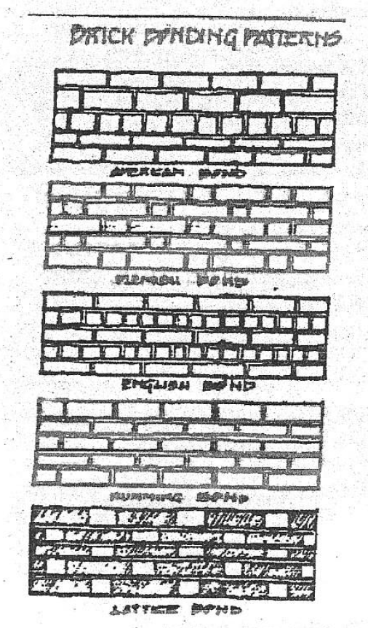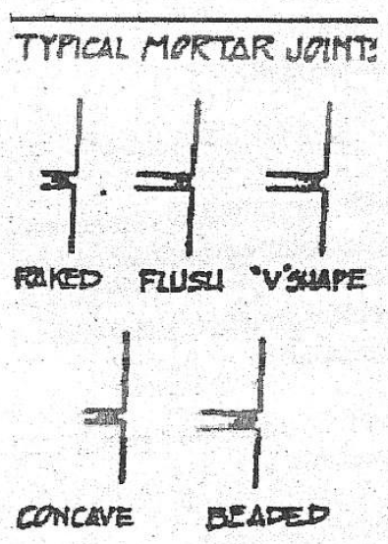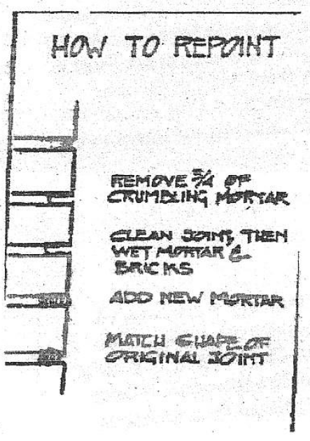

Before beginning any work, observe the profile of an existing mortar joint to determine the type of joint used. Close examination of both the vertical and horizontal joints will reveal the sequence of the tooling which affects the finished appearance of the wall. Repointing mortar must match the color, texture, strength, joint width and joint profile of the existing historic masonry.

The removal of existing deteriorated mortar should be accomplished by hand, using a hammer and cold chisel. Remove the old mortar to a depth of one-half inch to one and one-half inches and spray away small, loose particles with a light, quick stream of water.

A good starting point for most buildings constructed in the 1800s is a repointing mortar mix containing a ratio of 3:4:8 (Portland cement:lime:sand). Mortar mixes with a high percentage of Portland cement should not be used on buildings constructed prior to 1900. The color of the repointing mortar should match the unweathered interior portions of the historic mortar. The simplest way to check the match is to make a small sample of the proposed mix and allow it to Cure; this sample is then broken open and the broken surface is compared to the unweathered interior portions of the historic mortar. If available sand does not produce an acceptable color match, it may be necessary to use a modern mortar pigment, and, in fact, some historic mortars did use such additives.

In choosing a contractor or mason, perhaps the best way to award the contract is for this individual to demonstrate his or her skill in a test panel: a small demonstration section of joint preparation and repointing actually done on the historic masonry.

The test panel should be carefully selected to include all types of masonry, joint styles, and types of problems to be encountered on the job. Usually a 3 foot by 6 foot area located in an inconspicuous yet readily accessible place can be tested.

Siding
Historic materials should be repaired rather than replaced. Care should be taken not to damage, remove, or obscure the architectural features or character of the structure.
Deteriorated siding material should be replaced with material used in original construction, or with materials that resemble the appearance of the old as closely as possible. Wood or wood-like composite cornerboards, trim and fascia are preferred. Resurfacing frame buildings with inappropriate new material, such as artificial stone, artificial brick veneer, or asbestos and asphalt shingles, should not be done.
Synthetic or artificial siding (metal, vinyl, plastic) is often considered as an alternative to exterior painting. It is available in a variety of colors, textures, and widths. Although sometimes seen in historic districts, if not applied properly, it may cause permanent damage to the structure it is intended to protect. The use of this material also may result in lower property values, costly and irreversible changes in the character of the property, and is almost always inferior in appearance to painted wood.
Preserving historic siding material begins with the undertaking of a routine maintenance program which generally involves the least amount of work needed to preserve the materials and features of the building. Maintenance of a frame building would include caulking and painting, or where paint is extensively cracking and peeling, its removal and the re-application of a protective paint.

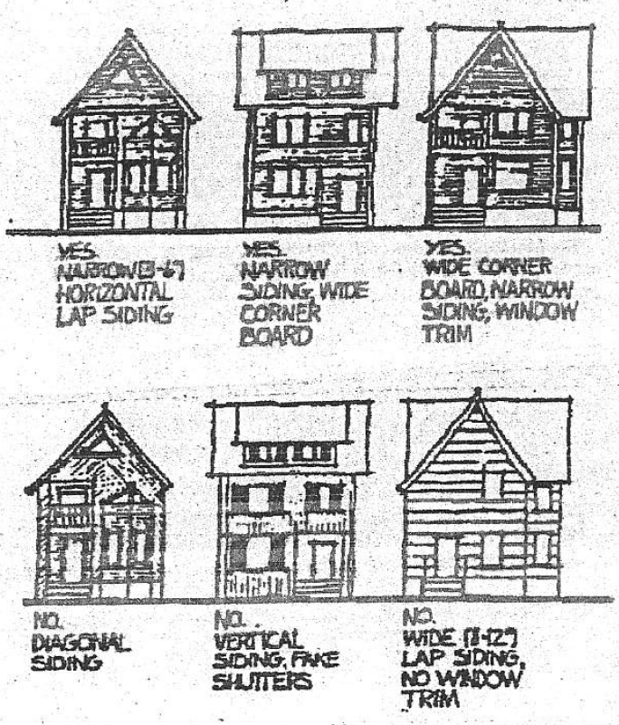

Replacing sound or repairable historic siding-material is never recommended. However, if the historic material cannot be repaired because of the extent of deterioration or damage, then it will be necessary to replace it. The preferred treatment is always replacement in kind, that is, with the same material. A substitute siding material, such as aluminum or vinyl, should only be considered if the form, detailing and overall appearance (size, profile and finish) of the substitute material conveys the visual appearance of the historic material and the application of the substitute material does not damage, destroy or obscure historic features.

There are, however, also certain disadvantages in the use of aluminum or vinyl siding, and these factors should be carefully considered before a decision is made to use such a material rather than the preferred replacement with new wood siding which duplicates the old.

Aluminum and vinyl sidings are frequently applied to buildings in need of maintenance and repair. This can result in concealing problems which are the early warning signs of deterioration. Minor uncorrected problems can progress to the point where expensive, major repairs to the structure become necessary. The installation of any new siding will not solve problems of deterioration and rotting that are occurring within the wall.

It cannot be stressed enough that a cosmetic treatment to hide difficulties such as peeling paint, stains or other indications of deterioration is not a sound preservation practice; it is no substitute for proper care and maintenance.

Doors and Windows

Doors
The original doors and hardware should be retained, whenever practicable. Deteriorated doors can be dismounted and refinished, cracks and holes can be filled, surfaces can be relaminated, hinges can be repaired, and rotten frames can be replaced. Any original hardware on the door should also be retained and repaired whenever possible.

If the present door is too deteriorated or is not original, several alternatives exist for replacement. A similar exterior door from a side or rear entrance could be removed and installed on the front. Salvage yards are also a source for doors of the same style. If the old doors cannot be retained, the new door should duplicate as closely as possible the size, proportion, shape, and number of panels of the original door. Although not recommended, molding can also be added to an existing flush solid core door to give the appearance of a period door. Select a drawing or photograph of a door that is appropriate for the style of the house and substitute molding for raised panels and details.

Screen Doors
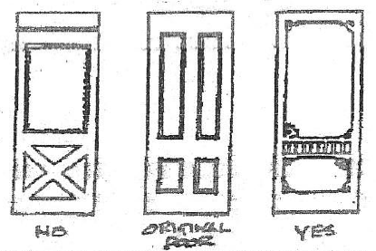
Screen doors allow the solid doors to be left open during the milder months, offering limited security and insect protection for the occupants, while allowing air and light into the entry-hall. Care should be taken when considering the installation of screen doors, however, since some architectural styles were not designed to incorporate them.
Screen and or storm doors should minimize interference with the appearance of the main door. If a screen door is to be installed, select a simple wooden door with as much open screen area as possible to minimize interference with the appearance of the main door. Paint it the same color as the main door to lessen contrast. The screen wire can also be spray painted if care is taken to insure that a fine mist spray is used, thus preventing paint from clogging the screen wire. Finally, keep the screen door the same size as the main door.

Windows
Windows are important to the overall design and character of a structure. Most Windows are double hung (or vertically sliding). The number of lights (or divisions) in a window sash varies with the architectural style of the structure. In the late 1800s, the two over two and one over one sash were introduced, creating an elongated effect. The pattern, size, proportion, casing, configuration of panes, muntin profile and associated details of the period should be maintained and/or duplicated whenever possible.
Existing historic windows should be retained if at all possible. Before replacing an entire window frame, examine it closely to determine if only the sill needs to be repaired or replaced. In many cases, the sill can be repaired by one of three methods, depending of the severity of the deterioration.
- If the sill contains numerous holes and cracks, treat the sill for one day with a wood preservative containing pentachlorophenol, then paint it liberally with linseed oil, and finally patch all holes and cracks with putty.
- If the sill has begun to rot, use marine epoxy, to stop the spread of rot, and then apply another marine product, such as “marine-tex,” to smooth the surface of the sill.
- If the deterioration is severe, apply several layers of plastic wood to build up the surface of the sill. Allow each layer to dry thoroughly before reapplication.
If the entire window frame cannot be saved, replace it with a window of the same size and with the same number of light divisions as the original. Window openings should not be blocked down or reduced in size to accommodate a smaller, standard replacement window. Likewise, the substitution of horizontally-designed picture windows is not appropriate. An exception permitting the use of plastic, vinyl, or metal windows or metal clad windows may be granted. If an exception is granted, those windows should mimic true divided light wood windows.
Double hung sash windows (two over two, four over four, or six over six) are to be used on facades that can be viewed from the public way. Six over six and other multilight sash should not be used unless appropriate to the architectural style of the structure. Snap-on mullions, which simulate the subdivisions between the lights, should not be used on any type of sash because their use provides a distorted image. Awning, casement, or sliding windows/doors will not be permitted on the front facade.

Storm Windows
If single glazed windows are used, insulation may be provided through the use of interior storm windows, “triple track” exterior storm windows or exterior storm windows with small wooden frames. The installation of exterior storm windows is a preferred rehabilitation treatment to achieve energy conservation. Exterior storm windows permit the retention of existing historic wooden windows and dramatically reduce their maintenance needs. A wooden sash with exterior aluminum storm window can outperform a replacement unit with thermal break and can be far more cost effective to install.
Triple track storms are recommended. Exterior storm windows should be finished to match the color of the historic window and frame. The meeting rails of storm sash must align with those of the existing windows. Interior storm windows should be used only when exterior storm windows significantly detract from the appearance of the building.

Roofs
Roofing materials for homes in the Historic District ideally should be wooden shingle, wooden shake, slate, or standing seam metal; however, the use of composite roofing material may also be acceptable. If an exception permitting composite material is granted, the roof should be a premium grade (no less than 300 lb. per square) and closely resemble natural material (weathered wood blend or antique slate blend colors). If applying composite roofing, the valleys should be metal--not woven. Wood roofs should be treated with fire retardant material.
The roof pitch for gable roofs should be no less than 7/12 (7 inches vertically for every 12 inches horizontally). Roof styles other than gable will also be considered. Roof overhangs of at least 6 inches are common, as are cornice returns.
Fascia and soffit ideally should be constructed of wood. An exception permitting the application of newer construction materials for the fascia or soffit may be granted if molding or other existing cornice details is not obscured. If the exception is granted, the surface should be smooth and have the appearance of a painted surface.
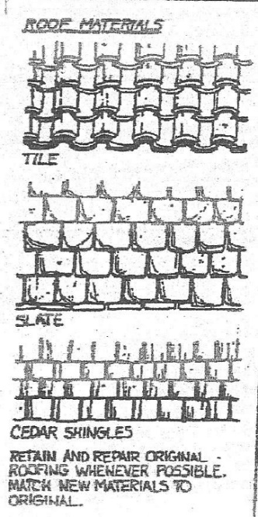
The original roof shape should be preserved and original roofing materials retained unless deteriorated. When partially re-roofing, deteriorated roof coverings should be replaced with new materials that match the old in composition, size, shape and texture. When entirely re-roofing, new materials should not be used which differ to such an extent from the old in composition, size, shape, color or texture that the appearance is altered.
The maintenance of roofs on historic properties can be costly and require frequent inspections. However, there is no substitute for the durability and appearance of slate and patterned or seamed tin. These materials should be valued by the property owner as an asset that contributes to property value.
Skylights visible from the front facade are not permitted.

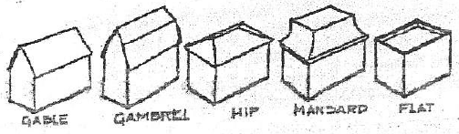

Chimneys
Chimneys should be constructed of brick or stone. Prefabricated or metal chimneys are not acceptable.

Porches and Decks
Most older residential structures have some sort of covered entrance, and these range from bracketed hoods to porches which wrap half-way around the structure. Large porches became popular during the late nineteenth century and were often added to earlier structures.
The porch structure itself includes the landing and other elements which support the roofed open area. Ornamentation such as turned or sawn wood balusters, fretwork, and columns define the character of most porches.Every effort should be made to retain as much of the original porch material as possible. If a porch must be replaced, it should be rebuilt to its original configuration. The usual setback distance and overall width of the original porch should also be maintained. Stoops, steps, railings, porches, and decks should be consistent with the historic style of the building.
Most porches were originally constructed of wood, supported by brick piers. Rehabilitation efforts should incorporate the use of these materials. Porches should not be replaced with inappropriate materials such as brick, concrete, concrete block, or inexpensive iron work. Doing so would most likely destroy the historical integrity of the structure as well as interrupt the rhythm of the streetscape. It is better to embark on a slow rebuilding project using original materials than to use unsuitable substitutes.
All wood surfaces must be painted, including ribbon boards, railings, and pickets. Unpainted pressure treated lumber or concrete will only be permitted when they are not viewable from the public way.
Steps to porches and decks are to be painted and have closed risers.
Front porches, including wrap-around, should be open. They may not be enclosed or screened in.
Second story or two story decks are not permitted.

Lattice
Latticework porch underskirtings should be made of ¼ inch thick wood strips, nailed at 90 degree angles and enclosed in a frame. Horizontal strips should be parallel to the porch floor. Diagonal orientation is permissible if site documented. Modern pre-fabricated heavy-weight lattice enclosed in wood frames may be substituted if approved.

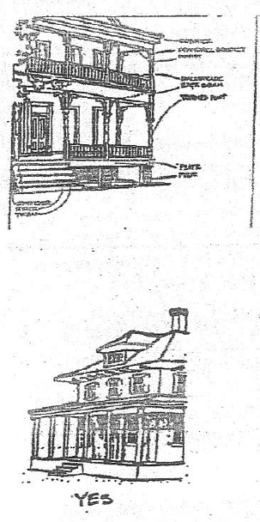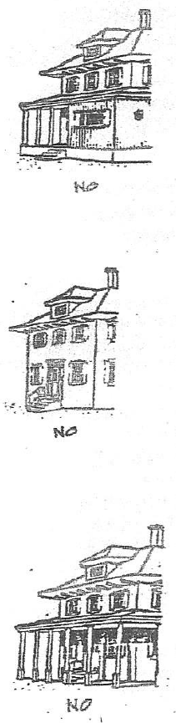

New Additions
Because a new exterior addition to a historic building can damage or destroy materials and change the buildings character, it should be constructed in a manner which preserves significant materials, features, and historic character.

Avoid constructing an addition on a primary or other character-defining elevation to ensure preservation of significant materials and features. Make sure that the size, scale, massing, and proportions of the new addition are compatible with the historic building to ensure that its form is not expanded or changed to an unacceptable degree.

Place the new addition on an inconspicuous side or rear elevation so that the new work does not result in a radical change to the form and character of the historic building. Consider setting an addition back from the historic building’s wall plane so that the form of the historic building can be distinguished from the new work. Plan the new addition in a manner that provides some differentiation in material, color, and detailing so that the new work does not appear to be part of the historic building.

Satellite Antennas
Under Federal rules and regulation, local governments are entitled to control the appearance and location of satellite dishes.
Satellite antennas or dishes should be as small as possible consistent with the requirements for reception and transmission. They should be located on the least visually prominent area of a structure, consistent with functional requirements.
Satellite antennas should be mounted as far back from the roof line of a building as possible to reduce visibility. The antennas cannot exceed the established building height limitation in the historic district.
If a satellite antenna must be located in a prominent visual position on the ground, screening with fencing materials or vegetation is required.

Signs
This section of the design guidelines is intended primarily for historic areas which are commercially zoned. Generally, signs should be compatible with the character of the neighborhood and blend with the character of the structures on or near which they are placed. In evaluating permit applications for signs, the following guidelines will be used:

- Signs should not conceal architectural detail, clutter the building’s image, or distract from the unity of the façade, but rather should complement the overall design.
- Sign materials should complement the material of the related building and/or the adjacent buildings. Surface design elements should not detract from or conflict with the related structure’s age and design.
- No façade should be damaged in the application of signs, except for mere attachment.

Fences
Fences have traditionally been a pleasing part of older neighborhoods, adding variety to the streetscape while marking property lines and outdoor spaces. A fence should be chosen to harmonize with the structure.
Chain link, split rail, and stockade fences are usually not appropriate. Post and rail or split-rail fences will not be permitted. Chain link fences visible from the public way are not permitted. Iron fences typical of the late 19th century will be permitted.
Wood fences should have vertical pickets. Fences are to be painted or covered with a solid stain. The finished side of the fence should face to the exterior (face the neighboring property or street).
Maximum height of any front yard fence will not exceed 3 feet. The rear corners of the structure will define the front yard.

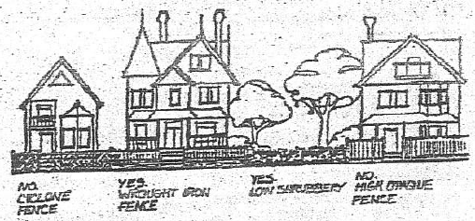

Demolition
The request to relocate or demolish historic properties sometimes arises. This often is seen as a last resort for an otherwise economically infeasible rehabilitation or higher use for the property.
The relocation or demolition of historic properties within historic districts is discouraged and should be considered only as a last resort. Applications for demolition of structures within the Historic District require approval by HDC. In addition, HDC may require property owners to maintain or repair structures within the historic district, if HDC considers the property to be subject to demolition by neglect.

Definition of Demolition by Neglect
Failure to maintain or repair structure that is not due to the owners financial inability to maintain or repair the structure. The lack of maintenance or repair has or will result in significant deterioration, permanent damage or unsafe conditions.

Shutters
Many structures are equipped with Shutters. When replacing or adding shutters to a structure, be sure that they appear to actually work. In other words, the shutters, if closed, should be large enough to cover the entire window and should be attached to the window, not the wall surface. Shutters constructed of wood are preferable. If the homeowner elects to use shutters, it is recommended those used on the front facade be made of wood, attached to the window frame and hinged. The shutters should be solid raised panel or louvered (adjustable or fixed). Vinyl shutters are decorative only and therefore cannot function as protection from the weather. Aluminum shutters do not resemble wood, dent easily, and wear quickly. An exception may be granted to permit the installation of vinyl shutters. The vinyl shutter must be of the proper scale (cover the window if closed).

