***Spirit of Laytonsville***

**14th**



**Pony Rides**

**Petting Farm Animals**

**Fabulous Cake Walk**

**Kids Tattoos**

**Paint a Rock Table**

**Citizen of the Year Award**

**Live Band**

**RAFFLE**

**Free Admission**

**Food (Includes Raffle)**

$5 Adults

$3 Children

$20 Family

*All proceeds benefit*

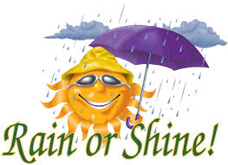

**Date: September 15, 2018  
Time: 5pm to 9pm  
 Food 5pm to 7pm  
 Program 7pm to 9pm  
Location: Laytonsville Town Hall**

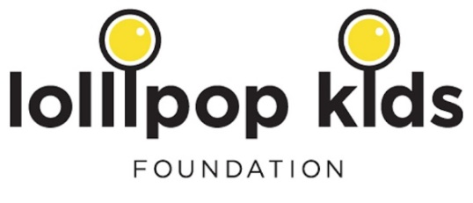

**Food, Fun, Live Music**

**& More…!**