***Strike Up the Band for Laytonsville’s***

**15th *ANNUAL PICNIC***

**Pony Rides**

**Petting Farm Animals**

**Fabulous Cake Walk**

**Balloon Artist**

**Face Painting**

**Citizen of the Year Award**

**Live Band - Jambone**

**Door prizes!!**

**Free Admission**

**Food available for purchase from the delicious**

***Corned Beef King***

**Food Truck**

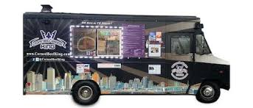

**Drinks, snacks & dessert provided**

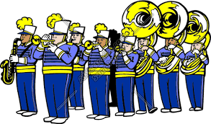

***Date:* September 21, 2019  
*Time:* 5pm to 9pm  
 Food 5pm to 8:30pm  
 Program 7pm to 8pm  
*Location:* Laytonsville Town Hall**



***All proceeds go to support the***

***Gaithersburg High School Band!***